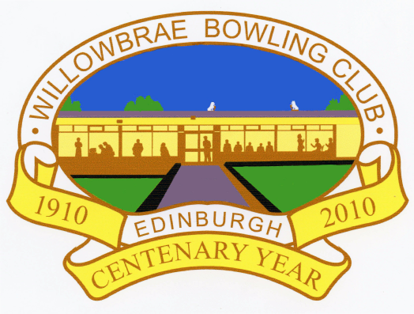
QUIZ NIGHT
SATURDAY 19th NOVEMBER @ 7pm
MUSIC HISTORY
GEOGRAPHY
GENERAL KNOWLEDGE
FILM & TV
Enter as a team or come along and join up with others

£2 per person – Maximum 6 per Team
Contact 07766 781071 to enter

